***Learning report of “how to write introduction”***

1. 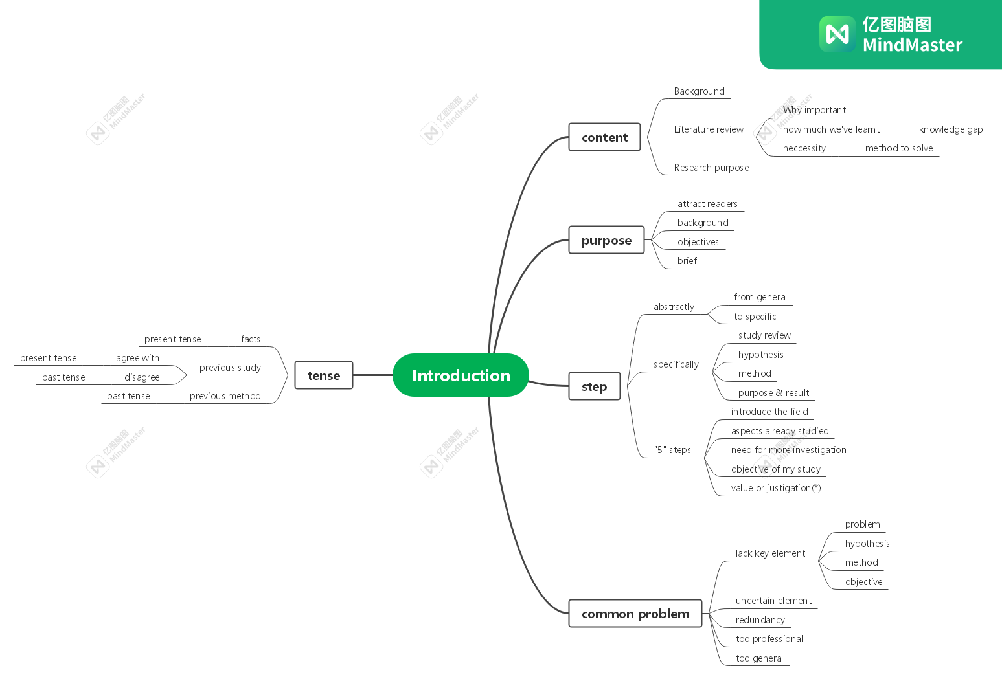**Mind map of my notes**
2. **Learning outcomes**

* A good introduction is half the success of a paper
* Introduction should let the reader understand the research background, research purpose, research necessity
* Steps of writing introduction should be from broad to specific.